**Question1:**

**Code:**

/*

Name: !you

Registration No: SP21-BCS-OO2

Question 1: Stocks calculation

*/

import java.util.Scanner;

public class LabQ1{

public static void main(String[] args) {

Scanner input = new Scanner(System.in);

System.out.println("Enter the number of shares sold: ");

double shares = input.nextInt();

System.out.println("Enter the purchase price of each share: ");

double purchasePrice = input.nextInt();

System.out.println("Enter the selling price of each share: ");

double sellingPrice = input.nextInt();

double amountInvested = shares * purchasePrice;

double amountEarned = shares * sellingPrice;

System.out.println("The total amount invested is: " + amountInvested);

double serviceProfit = amountEarned * 0.015;

System.out.println("The total service charges (on buy and sell) are: " + (amountInvested * 0.015 + amountEarned * 0.015));

double amountGainOrLost = amountEarned - amountInvested;

System.out.println("The total amount gained or lost is: " + amountGainOrLost );

System.out.println("The total amount after selling the stock is: " + ((amountInvested + amountGainOrLost) - serviceProfit));

}

}

**Output:**

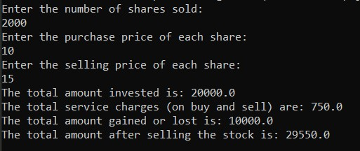

**Question2:**

**Code:**

/*

Name: !you

Regstration No: SP21-BCS-OO2

Question 2: Calculation cost of painting and installing carpet

*/

import java.util.Scanner;

public class LabQ2{

public static void main(String[] args) {

Scanner input = new Scanner(System.in);

// Taking room dimensions

System.out.println("Enter the length of the room (in feet): ");

double length = input.nextInt();

System.out.println("Enter the width of the room (in feet): ");

double width = input.nextInt();

System.out.println("Enter the height of the room (in feet): ");

double height = input.nextInt();

double volumeRoom = ((length * height) * 2) + ((width * height) * 2);

double areaRoom = length * width;

// Taking door dimensions

System.out.println("Enter the width of the Door (in feet): ");

double widthDoor = input.nextInt();

System.out.println("Enter the height of the Door (in feet): ");

double heightDoor = input.nextInt();

double volumeDoor = widthDoor * heightDoor;

// Taking window 1 dimensions

System.out.println("Enter the width of the Window (in feet): ");

double widthWindow = input.nextInt();

System.out.println("Enter the height of the Window (in feet): ");

double heightWindow = input.nextInt();

double volumeWindow = widthWindow * heightWindow;

// Taking window 2 dimensions

System.out.println("Enter the width of the Window 2 (in feet): ");

double widthWindow2 = input.nextInt();

System.out.println("Enter the height of the Window 2 (in feet): ");

double heightWindow2 = input.nextInt();

double volumeWindow2 = widthWindow2 * heightWindow2;

// Taking Book shelf dimensions

System.out.println("Enter the width of the Book Shelf (in feet): ");

double widthShelf = input.nextInt();

System.out.println("Enter the height of the Book Shelf (in feet): ");

double heightShelf = input.nextInt();

double volumeShelf = widthShelf * heightShelf;

// inputing cost of paint

System.out.println("Enter the cost (per square foot) of painting walls: ");

double costWalls = input.nextInt();

// inputing cost of carpet

System.out.println("Enter the cost (per square foot) of carpet: ");

double costCarpet = input.nextInt();

// calculating cost of paint

double costPaint = (volumeRoom - (volumeDoor + volumeShelf + volumeWindow + widthWindow2));

System.out.println("Cost of paining room would be $: " + (costPaint * costWalls));

// calculating cost of carpet

System.out.println("Cost of carpet for room would be $: " + (areaRoom * costCarpet));

}

}

**Output:**

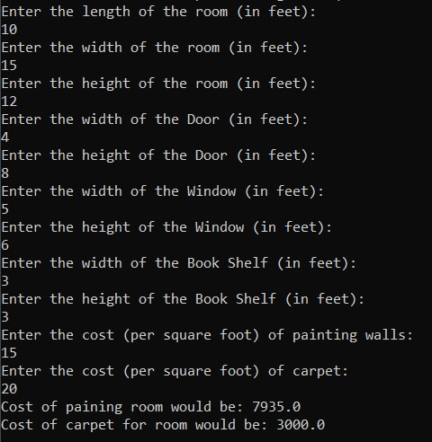

**Question3:**

**Code:**

/*

Name: !you

Regstration No: SP21-BCS-OO2

Question 3: Chess game

*/

import java.util.Scanner;

public class LabQ3{

public static void main(String[] args) {

Scanner input = new Scanner(System.in);

System.out.print("Enter a number (1-8) for the first row: ");

int row1 = input.nextInt();

System.out.print("Enter a number (1-8) for the first column: ");

int column1 = input.nextInt();

System.out.print("Enter a number (1-8) for the second row: ");

int row2 = input.nextInt();

System.out.print("Enter a number (1-8) for the second column: ");

int column2 = input.nextInt();

if((row1 - row2 <= 1) && (column1 - column2 <= 1) && ((row1 != column1 && row2 == column2) || (row1 == column1 && row2 != column2))){

System.out.print("Yes! the movement is possible");

}

else{

System.out.print("Nope! The movement is not possible");

}

}

}

**Output:**

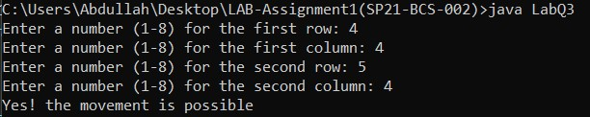

**Question4:**

**Code:**

/*

Name: !you

Regstration No: SP21-BCS-OO2

Question 4: Divisible number check

*/

import java.util.Scanner;

public class LabQ4{

public static void main(String[] args) {

Scanner input = new Scanner(System.in);

System.out.println("Enter a number: ");

int num = input.nextInt();

System.out.println("The number is divisible by both 5 and 6: " + (num % 5 == 0 && num % 6 == 0));

System.out.println("The number is divisible by 5 or 6: " + (num % 5 == 0 || num % 6 == 0));

System.out.println("The number is divisible by either 5 or 6 but not both: " + (num % 5 == 0 ^ num % 6 == 0));

}

}

Output:

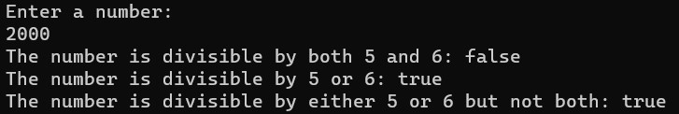

**Question5**

**Code:**

/*

Name: !you

Regstration No: SP21-BCS-OO2

Question 5: Tax Calculation

*/

import java.util.Scanner;

public class LabQ5{

public static void main(String[] args) {

Scanner input = new Scanner(System.in);

System.out.println("Enter your pay: ");

double pay = input.nextDouble();

System.out.println("Enter your Name: ");

String name = input.next();

double fedralTax = pay * 0.15;

double stateTax = pay * 0.035;

double socialSecurity = pay * 0.0575;

double medicalTax = pay * 0.0275;

double pensionPlan = pay * 0.05;

double healthInsurance = 75;

double netPay = fedralTax + stateTax + socialSecurity + medicalTax + pensionPlan + healthInsurance;

System.out.println("\n" + name);

System.out.printf("%-25s $ %5.2f\n","Gross Amount:", pay);

System.out.printf("%-25s $ %7.2f\n","Federal Tax:", fedralTax);

System.out.printf("%-25s $ %7.2f\n","State Tax:", stateTax);

System.out.printf("%-25s $ %7.2f\n","Social Security Tax:", socialSecurity);

System.out.printf("%-25s $ %7.2f\n","Medicare/Medicaid Tax:", medicalTax);

System.out.printf("%-25s $ %7.2f\n","Pension Plan:", pensionPlan);

System.out.printf("%-25s $ %7.2f\n","Health Insurance:", healthInsurance);

System.out.printf("%-25s $ %7.2f\n","Net Pay:", netPay);

}

}

Output:

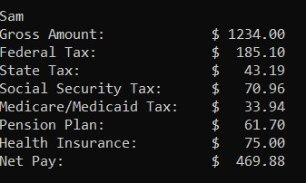

**Question6**

**Code:**

/*

Name: !you

Regstration No: SP21-BCS-OO2

Question 6: Bank Transaction

*/

import java.util.Scanner;

public class LabQ6{

public static void main(String[] args) {

Scanner input = new Scanner(System.in);

System.out.println("Enter amount for transaction: ");

int amount = input.nextInt();

System.out.println("Enter the total amount: ");

double totalAmount = input.nextDouble();

double amountTax = amount - 0.05;

if(amount % 5 == 0 && amount <= totalAmount){

System.out.printf("%5.2f\n", amountTax);

System.out.printf("%5.2f", totalAmount);

}

else{

System.out.println("You can not proceed the transaction");

}

}

}

Output:

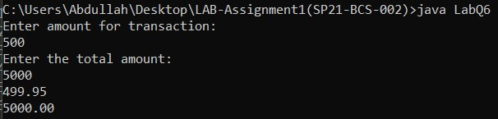

**Question7**

**Code:**

/*

Name: !you

Regstration No: SP21-BCS-OO2

Question 7: Checking palindrome

*/

import java.util.Scanner;

public class LabQ7{

public static void main(String[] args) {

Scanner input = new Scanner(System.in);

System.out.println("Enter a three digit integer: ");

int integer = input.nextInt();

int firstInteger = integer / 100;

int secondInteger = integer / 10;

secondInteger = secondInteger % 10;

int thirdInteger = integer % 10;

int setInt3 = thirdInteger * 100;

int setInt2 = secondInteger * 10;

int setInt1 = firstInteger * 1;

int allSet = setInt1 + setInt2 + setInt3;

System.out.println(allSet);

if(integer == allSet){

System.out.println("You win");

}

else{

System.out.println("You lose");

}

}

}

Output:

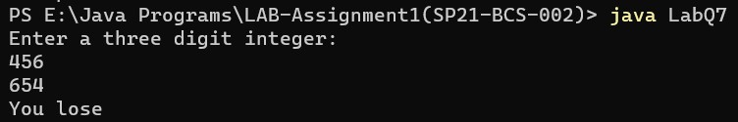

**Question8**

**Code:**

/*

Name: !you

Regstration No: SP21-BCS-OO2

Question 8: Shipping Package

*/

import java.util.Scanner;

public class LabQ8{

public static void main(String[] args) {

Scanner input = new Scanner(System.in);

System.out.print("Enter the weight of packages purchased: ");

int packageWeight = input.nextInt();

if(packageWeight <= 1){

System.out.println("The shipping charges would be: $3.50 ");

}

else if(packageWeight > 1 && packageWeight <= 3){

System.out.println("The shipping charges would be: $5.50 ");

}

else if(packageWeight > 3 && packageWeight <= 10){

System.out.print("The shipping charges would be: $8.50 ");

}

else if(packageWeight > 10 && packageWeight <= 20){

System.out.print("The shipping charges would be: $10.5 ");

}

}

}

Output:

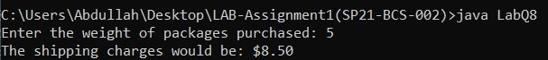

**Question9**

**Code:**

/*

Name: !you

Regstration No: SP21-BCS-OO2

Question 9: Zeller's congruence

*/

import java.util.Scanner;

public class LabQ9{

public static void main(String[] args) {

Scanner input = new Scanner(System.in);

int h;

System.out.print("Enter month: ");

int m = input.nextInt();

System.out.print("Enter day of month: ");

int q = input.nextInt();

System.out.print("Enter the year: ");

int year = input.nextInt();

int j = year / 100;

int k = year % 100;

if(m == 1){

m = m + 12;

k = k - 1;

}

else if(m == 2){

m = m + 13;

k = k - 1;

}

h = (q + 26 * (m + 1) / 10 + k + k / 4 + j / 4 + 5 * j) % 7;

if(h == 0){

System.out.println("Day of the week is: Saturday");

}

else if(h == 1){

System.out.println("Day of the week is: Sunday");

}

else if(h == 2){

System.out.println("Day of the week is: Monday");

}

else if(h == 3){

System.out.println("Day of the week is: Tuesday");

}

else if(h == 4){

System.out.println("Day of the week is: Wednesday");

}

else if(h == 5){

System.out.println("Day of the week is: Thursday");

}

else if(h == 6){

System.out.println("Day of the week is: Friday");

}

}

}

Output:

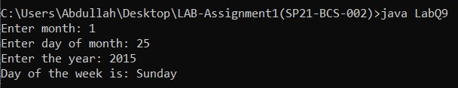

**Question10**

**Code:**

/*

Name: !you

Regstration No: SP21-BCS-OO2

Question 10: Checking Point

*/

import java.lang.Math;

import java.util.Scanner;

public class LabQ10{

public static void main(String[] args) {

Scanner input = new Scanner(System.in);

int x1 = 0;

int y1 = 0;

int radius = 10;

System.out.print("Enter the x point: ");

int x2 = input.nextInt();

System.out.print("Enter the y point: ");

int y2 = input.nextInt();

double distance = (x2 - x1) * (x2 - x1) + (y2 - y1) * (y2 - y1);

distance = Math.sqrt(distance);

if(distance <= radius){

System.out.print("The point: " + x2 + " and " + x1 + " is in the circle");

}

else if(distance > radius){

System.out.print("The point: " + x2 + " and " + x1 + " is not in the circle");

}

}

}

**Output:**

